Power BI Test Instructions
Technical Requirements: Microsoft Power BI Desktop version 2.111.265.0 or greater. Link to download: https://www.microsoft.com/en-us/download/details.aspx?id=58494

Instructions: This test should take between 0.5-2 hours based on skill level and detail taken to complete. Please follow the 9 steps and submit in response your PBIX file as well as this word document with the open response answers.
Note: We will not be replying with feedback on test results to protect the integrity of the test

Import data
- Open new Power BI dashboard and import source tables from ‘PBI Test Source Tables.xlsx’ into Power BI via Power Query Editor. Make any necessary changes to tables.
- Completed.

- In Power Query, make a new column that will identify the last month in the calendar and adds a label “Current”, and the month before labeled “Prior”. Then all other months use the field ‘Month’. Name the new field “Month Select”.
- Completed.

Set up Data Model
- Define the fact tables and dimension tables
- Completed.

Open Response:
- Fact tables: “Sales”
- Dimension tables: “Product”, “Store” and “Calendar – From Sales”
- Comments:
  - I am not uploading the table “Calendar” because I prefer to create the calendar table from the transactional data (Fact tables), then I created another one referenced from “Sales” <>with the same structure and metadata than “Calendar”.
  - And I am not uploading the table “Customer” because it had a relationship 1:1 with “Sales” then I just merged them and add the values to the facts table.

- Connect all dimension tables to fact tables
- Completed.
Open Response:
- What keys did you use and explain why you selected the relationship you did?
  - [Store] – [Sales]: “StoreID” (renamed “Store ID”) direct relationship M:1
  - [Product] – [Sales]: “ProductID” (renamed “Product ID”) direct relationship M:1
  - [Calendar – from Sales] – [Sales]: “Date”, direct relationship 1:M
  - There is not relationships from [Customer] because it was a relationship 1:1 with [Sales] linked through the field “ID” then I preferred to merge them and add the [Customer] values to [Sales] and remove [Customer] of the model.
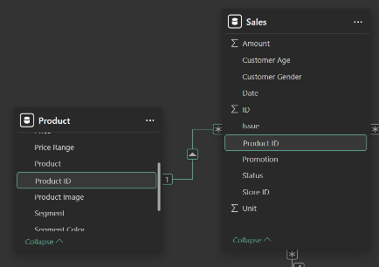
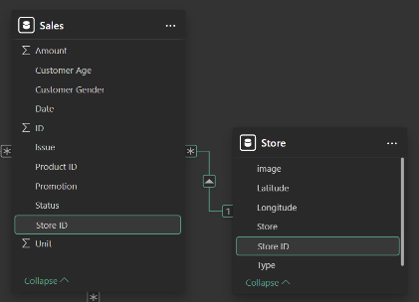
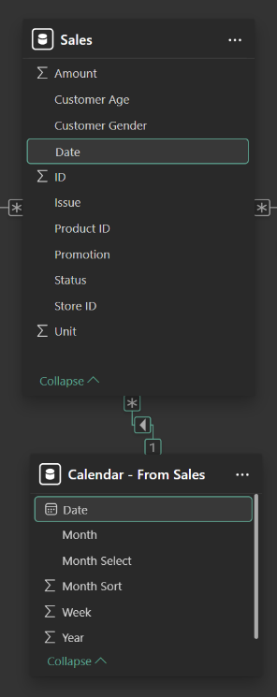

- Calculate the net sales $ and net sales quantity
- To get the net sales I apply Sum product of [Amount]x(1+[Discount]) to get the real value after applying the [Promotion].
  - $ Sales: $1,720,020.00
  - $ Net Sales: $1,670,819.10
- To get the net sales quantity I just sum “Units” in [Sales].
  - # Quantity: $34,696

Create visuals
- Create a dashboard with 4 visuals that shows you a breakdown of net sales $. The 4 visuals are:
  - Top left, Stacked bar of net sales by store stacked by category.
    - Completed.
  - Top right, trend chart of net sales by date.
    - Completed.
  - Bottom left, treemap of net sales breaking down key elements of the product in the best way possible.
    - Completed.
  - Bottom right, table of all useful data at lowest level of granularity as well as net sales
    - Completed.
- Add a button to toggle between Net Sales $ and Net Sales Qty (label buttons $ and Qty) and replace the net sales $ measure with this dynamic measure in the 4 visuals.
  - Completed.
  - Use a single measure to change the purpose of the analysis in the visualizations is not useful when we use different formats because we lost the capacities to format the Titles, Magnitudes or symbols (like currencies).
  - In this case, for example, we have two different formats (Whole numbers #,### and Currencies $). By the applied way, we must show all our labels in Numeric (#,###.#). And, In addition, we have to create additional measures to edit the text of the titles of the visualizations for a better user experience.
  - For these cases, it is better to use bookmarks to show/hide different visualizations with all the proper titles, axis titles, formats of the labels, etc.
- Add slicer on “Month Select” to only show current month in all visuals except for trend.
  - Completed.
- Add relevant dimension fields to filter pane. Clean up filter pane so it just shows filters on all pages. Color background of filter pane to be light blue.
  - Completed.

